**Lokmanya Tilak Jankalyan Shikshan Sanstha’s**

**PRIYADARSHINI COLLEGE OF ENGINEERING,**

**NAGPUR**

**DEPARTMENT OF ARTIFICIAL INTELLIGENCE**

* **DATA SCIENCE 2023-2024**



**MINI-PROJECT REPORT**

*A report submitted on SMART WATER SYSTEM*

Project Guide: Prof. U.A.S Gani

|  |  |  |  |
| --- | --- | --- | --- |
| Sr. no. | Name | Roll No. | Signature |
| 1 | Prathamesh Nikam | 227 |  |
| 2 | Pratik Dhengre | 228 |  |
| 3 | Sagar Wagare | 229 |  |
| 4 | Sanskar Durbade | 230 |  |

**Lokmanya Tilak Jankalyan Shikshan Sanstha’s**

**PRIYADARSHINI COLLEGE OF ENGINEERING, NAGPUR**

**DEPARTMENT OF ARTIFICIAL INTELLIGENCE & DATA SCIENCE**



***CERTIFICATE***

This project addresses water quality issues and inequities through a community-centric approach. It incorporates a AI based water quality and health risk assessment tool

featuring a recommender system for potential waterborne diseases. The system utilizes remote sensing technology to monitor real-time water quality parameters. A smart water solution is also implemented to tackle intermitted and inequitable water supply.

**Introduction**

Water is essential for life and well being . However, water quality issues and inequities in access to safe water are major global challenges. This project aims to address these concerns by developing a community-eccentric approach that leverages AI, remote sensing . Being able to efficiently monitor water quality may be a significant instrument for guaranteeing secure and pure drinking supplies. Water quality is an important problem in our everyday life. We will investigate the use of an Arduino and a turbidity sensor to detect the quality of water in this project. A fluid’s cloudiness or haziness brought by a high number of individual particles is referred to as turbidity. Since turbidity frequently signals the existence of suspended particles and contaminants, monitoring it can be aid in the assessment of the quality of the water. You can simply test the quality of water by making your own turbidity meter using an Arduino and a turbidity sensor module.

***Components Required :-***

* [Solderless Breadboard](https://marobotic.com/product/400-tie-points-half-size-solderless-breadboard/)
* [Arduino UNO](https://marobotic.com/product/arduino-uno-r3-dip-board-with-usb-cable/)
* [16×2 LCD Display](https://marobotic.com/product/16x2-lcd-display/)
* [Turbidity Sensor Module](https://marobotic.com/product/turbidity-sensor-module/)
* [10k Variable Resistor](https://marobotic.com/product/10k-variable-resistor/)
* [100R Resistor](https://marobotic.com/product/5-pc-100r-100-ohm-resistance/)
* [Male to Male Jumper Wires](https://marobotic.com/product/male-to-male-jumper-wires-10cm/)
* [Male to Female Jumper Wires](https://marobotic.com/product/male-to-female-jumper-wires-10cm/)
* **9V Adapter**

**Proteus simulation**

Open the simulation file on Proteus 8. An Arduino UNO is used as a micro controller. A 16×2 LCD is used as display. It displays the turbidity value of water in first row. In second row, it shows the attributes of water like clean, dirty or very dirty. A turbidity sensor is used. The values are varied from turbidity sensor to check the code’s working before implementing it on hardware.

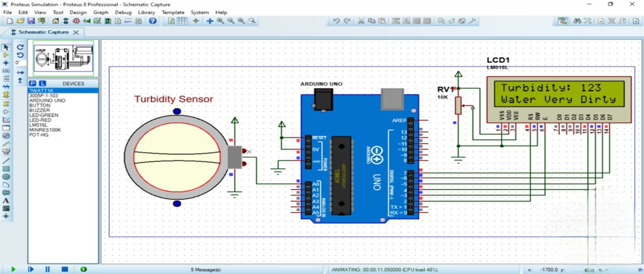

**Circuit diagram**

First of all, a 9 volts battery is used as power source. An Arduino UNO is used as a micro controller. A turbidity sensor is used. A 16×2 LCD used to display the turbidity value and quality status of water. A 10k variable resistor is used. Different water samples are taken in glass for testing.

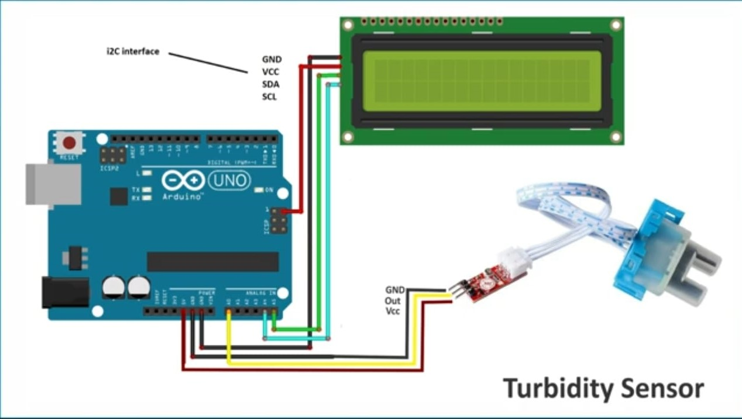

Hardware Live Project :-

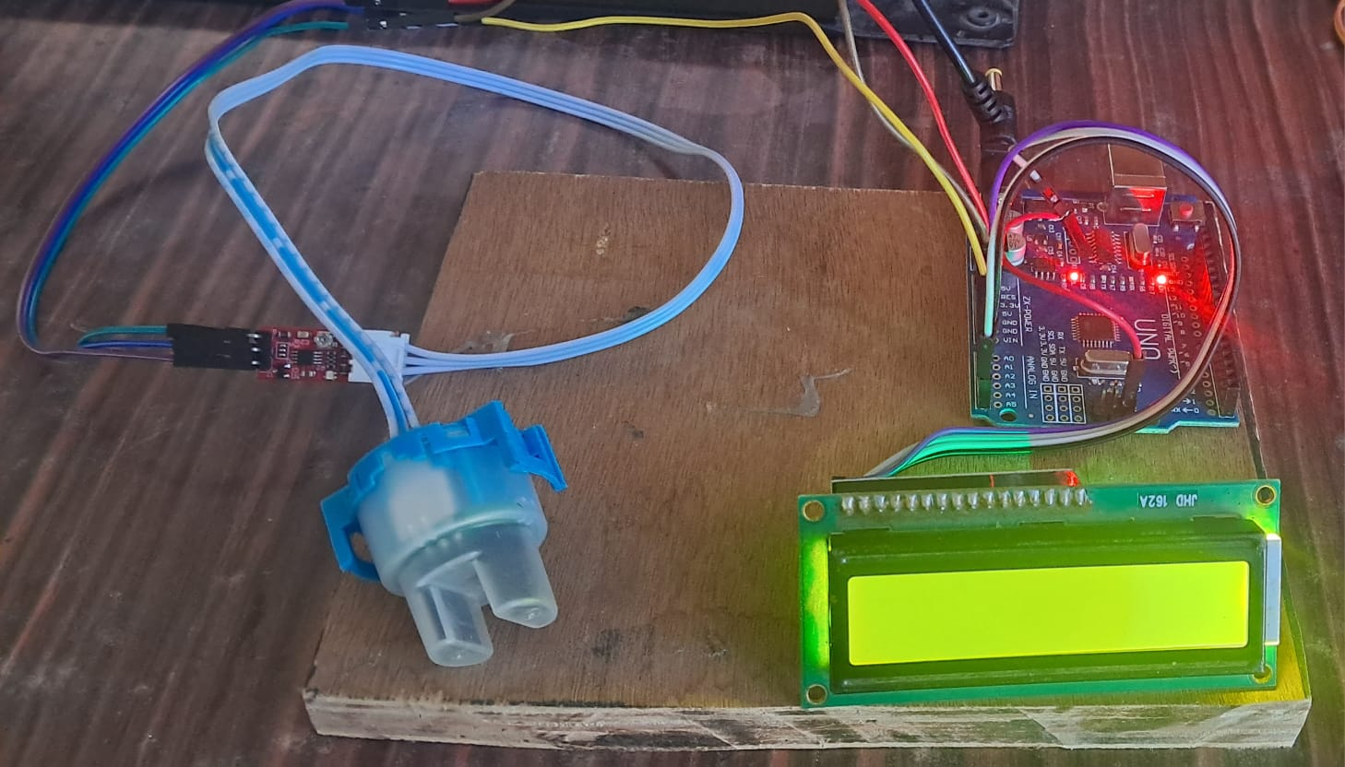

**Methodology**

Phase 1: Data Collection and analysis

1.Community Management:

* Conduct workshops and surveys to understand community water needs, concerns, and knowledge.
* Identity community leaders and establish a collaborative framework.
* Train community members in basic water quality data collection technique using low-cost sensors or citizen science kits.

2.Water Spatial Data Acquisition:

* Utilize remote sensing imagery to analyze historical and real-time water quality parameters.
* Develop Geo spatial models to identify areas with potential water quality risks.

Phase 2: System Development

1. Geo-AI Water Quality Assessment Tool:

* Develop a user-friendly web or mobile application.
* Integrate water quality data from community sensors, remote sensing , and existing government monitoring stations.
* Utilize machine learning algorithms to analyze water quality data from assess potential health risks associated with different contaminants.

2. Recommend-er System for Waterborne Diseases:

* Build a knowledge base linking water quality parameters to potential waterborne diseases.
* Develop an algorithm that recommends appropriate preventive measures or treatment options based on the assessed water quality risks.

Phase 3: Implementation and Monitoring

* Train community members on using the water quality assessment tool and interpreting results.
* Partner with local authorities to integrate real-time water quality data and community health.
* Monitor the effectiveness of the system in improving water quality and community health.
* Regular collect feedback from stakeholders and iterate onthe system based on their needs.

**Arduino IDE Code**

void setup() {

// initialize serial communication at 9600 bits per second:

Serial.begin(9600);

}

// the loop routine runs over and over again forever:

void loop() {

// read the input on analog pin 0;

int sensorValue = analogRead (20);

// print out the value you read;

Serial.println(sensorValue);

delay(100); // delay in between reads for stability

}

***Explanation:-***

This code is written in Arduino's C++ based language and is designed to read analog data from pin 20 (A20) of the Arduino board and then print that data to the serial monitor. Let's break it down line by line:

* 1. `void setup() { ... }`: This is a function that runs once when the Arduino is powered up or reset. In this case, it's used to initialize the serial communication at a baud rate of 9600 bits per second using the `Serial.begin(9600)` function.
* 2. `void loop() { ... }`: This is another function in Arduino that runs continuously after the `setup()` function finishes executing. Inside this function, there's a loop that repeats indefinitely.
* 3. `int sensorValue = analogRead(20);`: This line reads the analog voltage from pin A20 of the Arduino board and stores it in the variable `sensorValue`. The `analogRead()` function converts the analog input voltage into a digital value ranging from 0 to 1023.
* 4. `Serial.println(sensorValue);`: This line prints the value of `sensorValue` to the serial monitor. `Serial.println()` is a function that sends data to the serial port, which can be monitored on a computer using software like the Arduino IDE's Serial Monitor.
* 5. `delay(100);`: This line introduces a delay of 100 milliseconds between each iteration of the loop. This delay is added to stabilize the readings and prevent overwhelming the serial monitor with data.

In summary, this code continuously reads the analog voltage from pin A20 of the Arduino board, converts it to a digital value, and then prints that value to the serial monitor every 100 milliseconds.

***Expected Outcomes & Impact :-***

Expected outcomes and impacts of Smart Water Systems must be:-

* Improved water quality and health in the community: The project will use remote sensing technology to monitor real-time water quality parameters and a Geo-AI-based water quality and health risk assessment tool. This will help to identify potential waterborne diseases and take steps to prevent them.
* Tackled intermittent and inequitable water supply: An IoT-enabled smart solution will be implemented to manage water supply more effectively. This could involve measures such as leak detection and repair, as well as optimizing water pressure and flow rates.
* Community-based approach: The project is designed to be community-centric, which means that it will involve and empower community members to participate in monitoring and managing their water supply. This could lead to a greater sense of ownership and responsibility for water resources.

Overall, the expected outcomes of Smart Water Systems are to improve water quality, health, and equity in the community. The project is expected to have a positive impact on the lives of community members by providing them with safe and reliable drinking water.

* In our mini project – Titled as Smart Water Systems , We have used Turbidity value as a indicator to show the clarity of water . By using Turbidity value , we can exact value of clear our present water is there.
* Outcome –

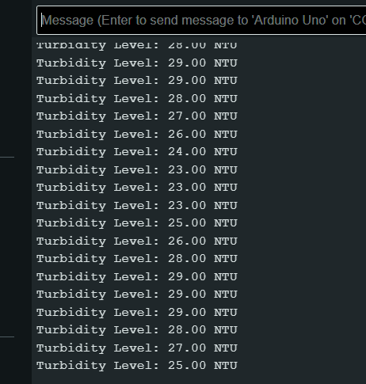

* Here , We can some other parameters as well like ph , water hardness ,etc.

**Conclusion**

For educational, environmental monitoring, or personal usage, this homemade turbidity meter might be a useful instrument for determining how clean a water supply is. You may build a customized water quality monitoring system and learn more about the water you use on a daily basis by following the instructions provided in this blog article. This activity may be enjoyable and informative, and it can help people gain a better understanding of environmental conservation and water quality, regardless of whether they are students, hobbyists, or environmental enthusiasts.